**Practical No.01**

**OBJECT:**

Write an Application to the Librarian to issue you some books from the library. Insert a table containing serial numbers, Book names, Author names, and Edition and print it.

**Procedure:**

* Click the start button → Microsoft Office Ms. Word.
* Create application file → Blank document [for opening file] or new.
* Write the format of application.
* [Create table] click insert → table 4 columns 3 rows.
* Place the data in the table.
* Save document] file → name → save.
* Close document] file→ close.

To,

The Librarian,

Government Degree College XYZ,

Karachi.

**Subject**: Requesting her to issue some books from the library.

Dear Madam,

With the most respect it stated that, I am a student of class XI computer Science with the roll number 611. The books which I require are specified below.

|  |  |  |  |
| --- | --- | --- | --- |
| **No.** | **Book Name** | **Author Name** | **Edition** |
|  | Alchemist | Paulo Coelho | 20th |
|  | The Kite Runner | Khaled Hosseini | 10th |
|  | To Kill a Mockingbird | Harper Lee | 50th |
|  | Pride and Prejudice | Jane Austen | 20th |

I would be extremely delighted on this act of kindness.

Yours Obediently,

XYZ.

**Practical No.02**

**OBJECT:**

Write an application to your principal asking him for your leaving certificate. Use Time Roman style.

**Procedure:**

* Click start menu→ All programs→ MS Office → MS Word.
* Write the format of application.
* (Styling) click home font size → font style.
* (Saving the document) office → save as →file name → save.
* Printing the document) click file → print → select number of pages and copies→ OK.
* Closing the document) file close.

To,

The Principal, Government Degree college, XYZ ,

Karachi.

Subject: For issuing a leaving certificate.

Respected Principal,

I hope this letter finds you well. I am writing to request my leaving certificate from [GOV Degree Collage XYZ ] as I plan to pursue further studies/employment opportunities/other reasons.

Full Name: [XYZ]

Class: [XI]

Roll No:[abc]

I kindly request you to expedite the process. Your prompt action will be greatly appreciated.

Thank you for your attention to this matter Sincerely, [XYZ]

Top of Form

**Practical No.03**

**OBJECT:**

Write a letter to your father requesting him to send you Rs 9000 for your hostel expenditure. Insert a table containing hostel charges, washing clothes, bus fair, and expenditures.

**Procedure:**

* Click start menu → All programs → MS Office → MS Word.
* (Create letter) file → New blank document (for opening new file).
* Write the format of the letter.
* (Create a table) clicks insert → table → 4 columns and 2 rows.
* Place the data in the table.
* (Save the document) file → save as file name → save.
* (Closing the document) file → close.

Dear father,

Assalam-u-Alaikum,

I hope this letter finds you in good health and spirits. I am writing to request your assistance regarding my hostel expenses. As you know, managing finances for my hostel expenditures has been challenging lately. Enclosed is a breakdown of the expenses:

|  |  |  |  |
| --- | --- | --- | --- |
| **Hostel Charges** | **Washing Clothes** | **Bus Fair** | **Daily Expenditures** |
| 5000 | 2000 | 1000 | 1000 |

Your support with Rs 9000 would immensely help alleviate the financial burden. I assure you of prudent use of the funds. Thank you for your constant support and guidance.

Your loving son,

Dated: dd/mm/yy

XYZ.

**Practical No.04**

**OBJECT:**

Write a letter to your friend thanking her for sending you a promotion

gift. Perform the following tasks on the letter.

* Page border
* Central Alignment
* Font style: Arial
* Font size: 13
* Use double line spacing.

**Procedure:**

1. Click start menu → All programs → MS Office → MS Word.
2. Office → New → Blank document (for spacing a new file).
3. Write the format of the letter.
4. Create page border. Click page design → Click page border → Select border → OK.
5. Double line spacing. Select the held text → Click line spacing 2.0.
6. Central Alignment. Select the held content → Click home → Central Alignment.
7. Save the document. File → Save as → File name → Save.
8. Save the document. Print → Select the number of pages and copies → OK.
9. Closing the document. Office → close.

**Government Degree College**

XYZ

Karachi,

My beloved friend,

Assalam-o-Alaikum

I hope this letter finds you well. I wanted to express my heartfelt gratitude for the delightful promotion gift you sent me. Your thoughtful gesture truly warmed my heart and made my promotion even more special. The [gift's description] is not only beautiful but also holds a special place in my heart as a token of our friendship. Your support and encouragement mean the world to me. I am incredibly fortunate to have a friend like you in my life. Once again, thank you from the bottom of my heart.

Warm regards,

[XYZ]

**Practical No.05**

**OBJECT:**

Write a paragraph on computer hardware, paste it five times and create a text box writing which font size and style you used.

**Procedure:**

* Click start menu All programs → Microsoft Office →Ms. Word.
* Office → New → Blank Document (For opening file).
* Write the paragraph on computer hardware.
* Paste it five times.
* For text box → Insert →Text box.
* Write what font style and size you used.
* Save the document. File →Save as → File name → Save.
* Printing the document. Print → select the number of pages and copies → OK.
* Closing the document. Office → OK.

Computer hardware comprises physical components like CPU, memory, storage, input/output devices, and connectors. CPU

Font Style: Berlin Sans FB Demi Font Size: 14

Font Style: Arial Black Font Size: 12

Computer hardware comprises physical components like CPU, memory, storage, input/output devices, and connectors. CPU processes data, memory stores

Font Style: Algerian Font Size: 16

Computer hardware comprises physical components like CPU, memory, storage, input/output devices, and connectors. CPU processes data, memory stores.

Font Style: Algerian Font Size: 16

Computer hardware comprises physical components like CPU, memory, storage, input/output devices, and connectors. CPU processes data

Font Style: Broadway Font Size: 14

Font Style: Agency FB Font Size: 14

Computer hardware comprises physical components like CPU, memory, storage, input/output devices, and connectors. CPU processes data

Font Style: Cascadia Code Light Font Size: 16

**Practical No.06**

**OBJECT:**

Write a paragraph of at least 15 lines, convert the document into two

columns and also insert any two clip art, insert data as the header at the center

of the page.

**Procedure:**

* Click start menu → All programs → Microsoft Office → MS. Word.
* Office → New → Blank document (for opening a new file).
* For header time and date to set automatically. Click insert → Header →
  + Date and Time → Automatically → OK.
* Convert the document into two columns.
* To convert the document. Page layout → Columns → Two.
* To insert Clip Art. → Insert → Search for → Go → OK.
* Save the document. Office → Save as → File name → Save.
* Printing a document. Office → Print → Select the number of pages and
  + copies → OK.
* Closing the document. File → Close

**July 27, 2024**

**Crypto Currency**

   
Cryptocurrency is a digital or virtual form of currency that relies on cryptography for security. Unlike traditional currencies issued by governments, cryptocurrencies operate on decentralized networks based on blockchain technology. Bitcoin, introduced in 2009 by an anonymous person or group known as Satoshi Nakamoto, was the first cryptocurrency and remains the most well-known. Since then, thousands of other cryptocurrencies, often referred to as altcoins, have been developed each with its own unique features and purposes. Ethereum, for example, introduced the concept of smart contracts, enabling developers to create decentralized applications (DApps). Cryptocurrencies offer several advantages, including lower transaction fees, faster cross-border transactions,

**Practical No.07**

**OBJECT:**

Write an invitation to a friend; invite her to your birthday party. Give a page border to your invitation; insert a graphic from the event category set landscape as the orientation save and print your document.

**Procedure:**

* Click start menu 🡪 Program 🡪 MS. Office 🡪 MS. Word.
* Office 🡪 New 🡪 Blank document. (for opening new file).
* Write on invitation to your friend.
* For page border. Click page layout 🡪 Design 🡪 Page border 🡪 Select OK.
* Closing the document. File 🡪 Close.

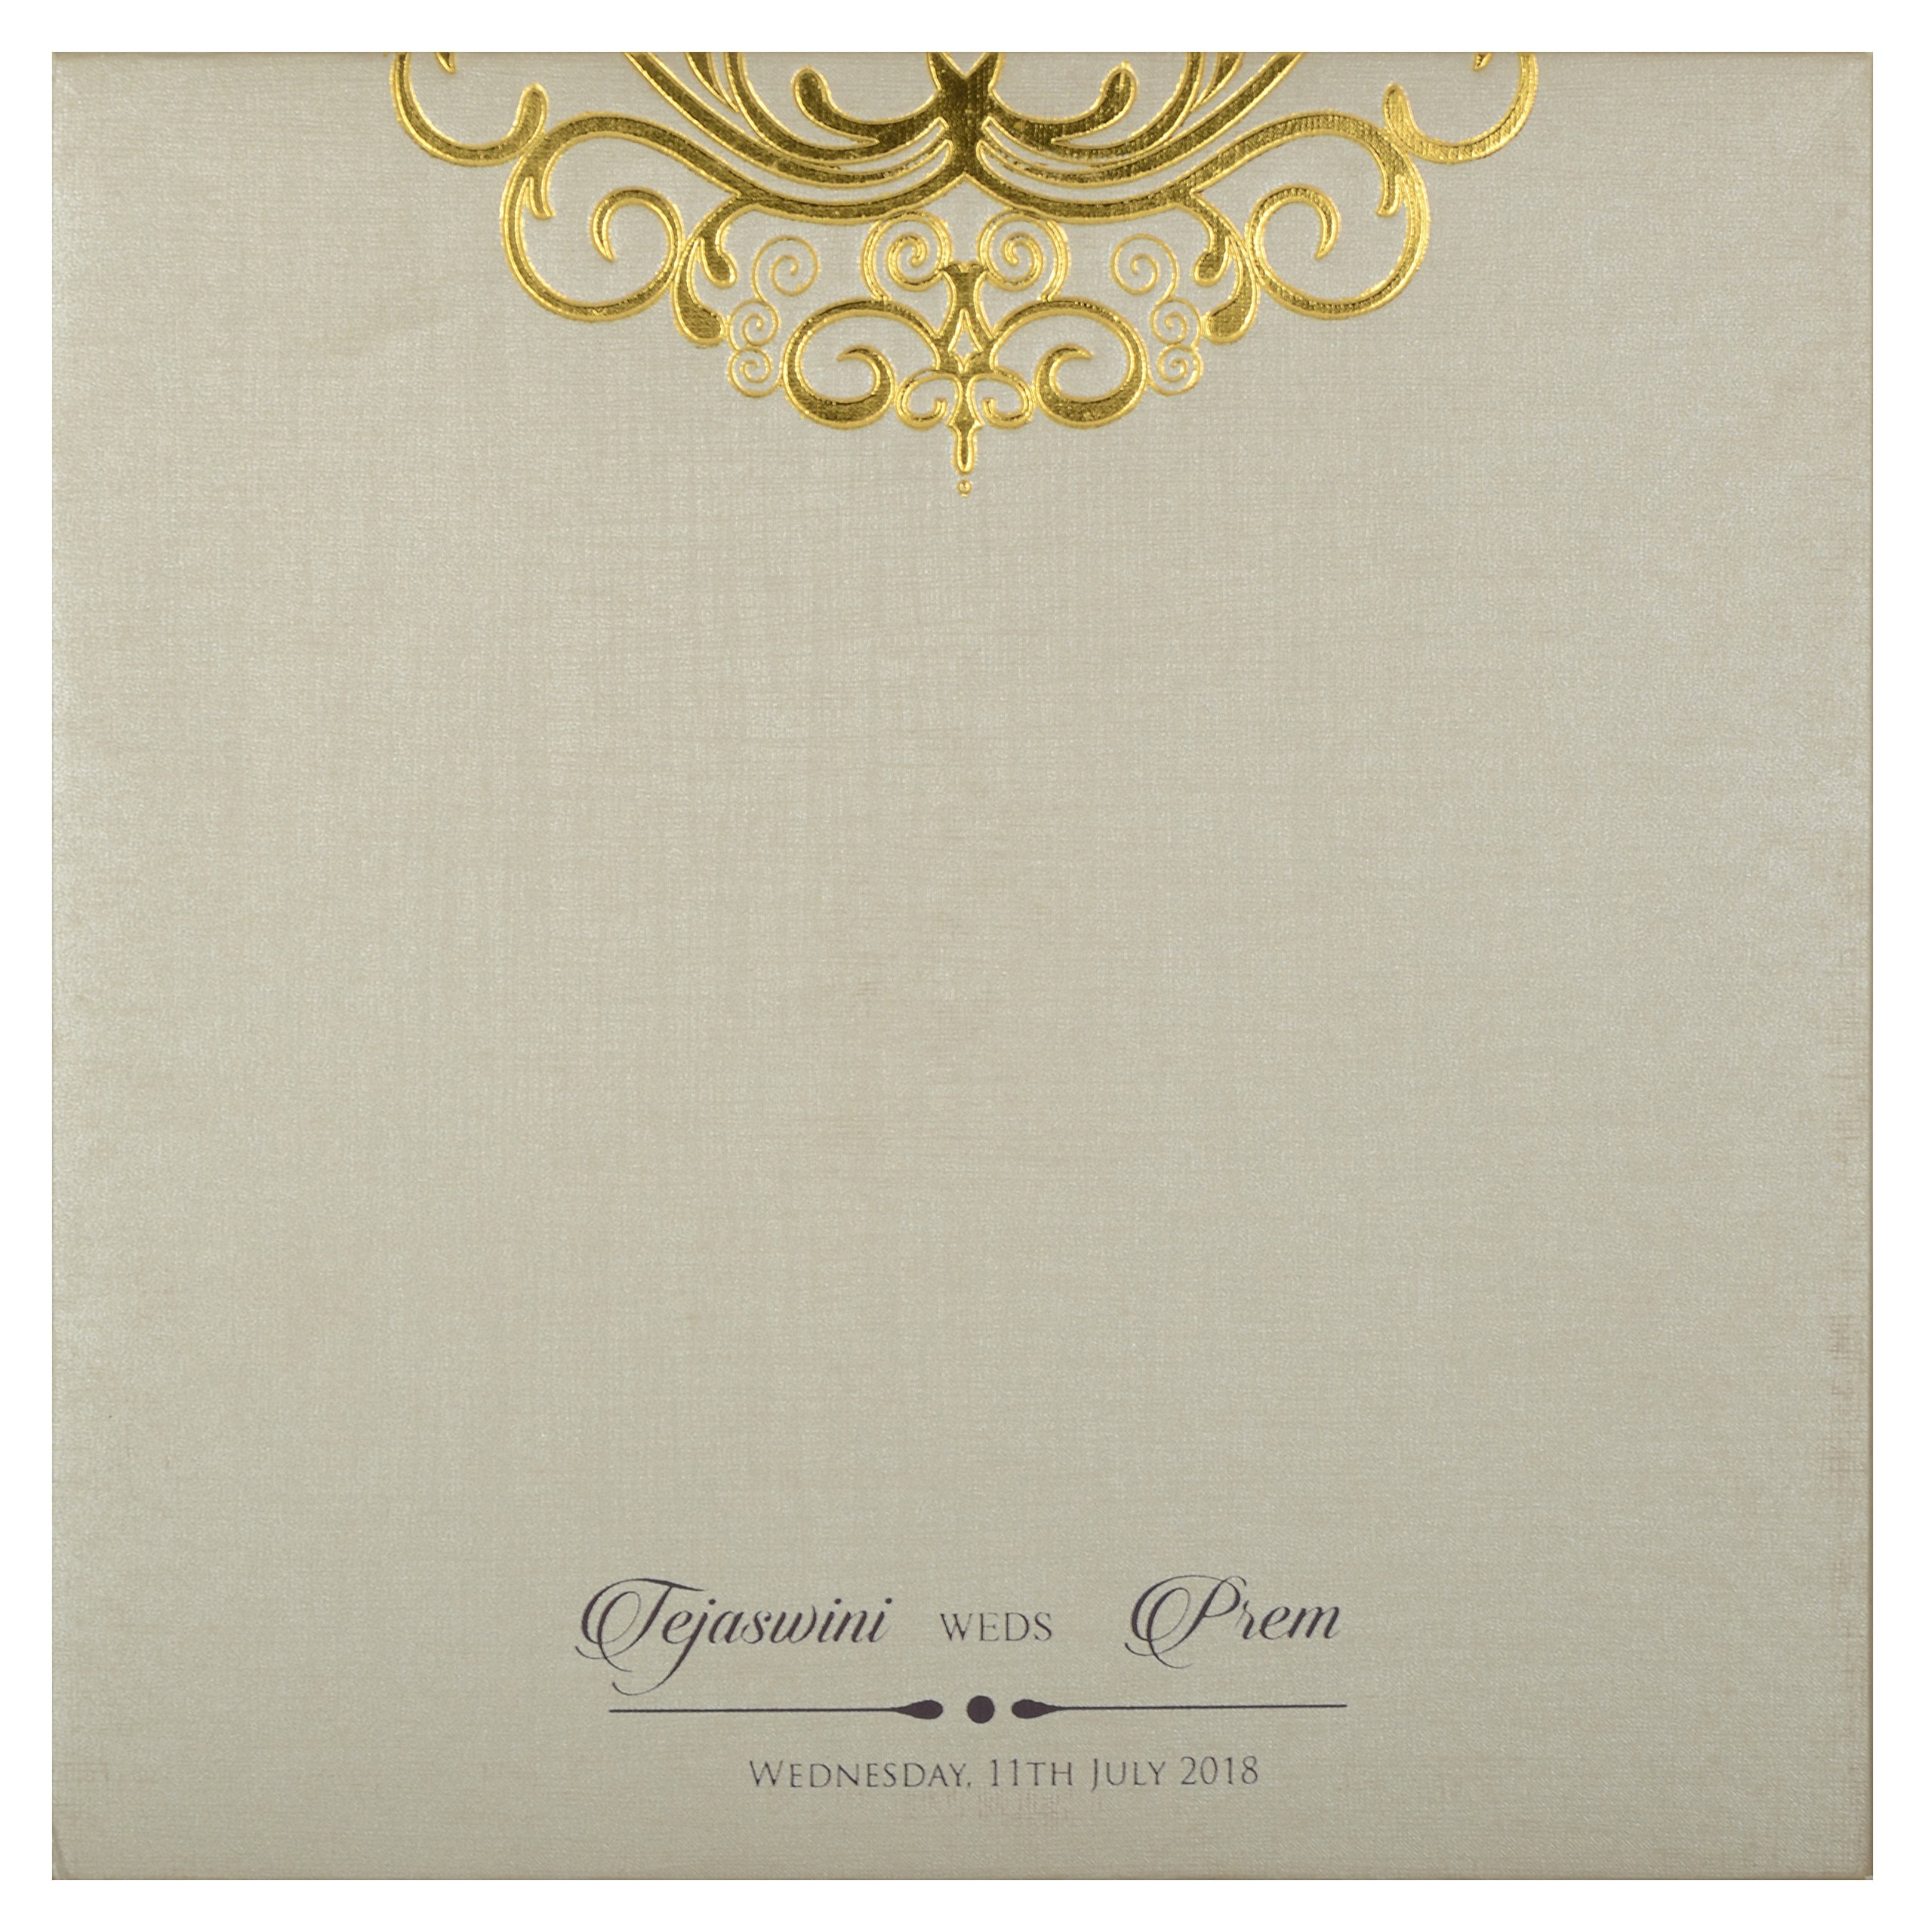

You Sweet Friend,

27 July 2024

Dear Friend,

I hope this message finds you well. I'm writing to invite you to my birthday party! 🎉 It's going to be a fantastic celebration with great food, music, and of course, wonderful company. I would be delighted if you could join me on [date] at [time] at [venue/address]. Your presence would truly make my day special.

Please RSVP by [2 May 2024] so we can make necessary arrangements. Feel free to bring along anyone you'd like to share the fun with!

Looking forward to celebrating with you.

With Warm regards,

XYZ

**Practical No.08**

**OBJECT:**

Type the given phases of the area of the circle, the formula for finding mean, formula of water, and square formula for numbers. Write FORMULA as the header of the page.

**Procedure:**

* Click the start menu → All programs Microsoft office → MS word.
* Office →New →Blank document (for opening a new file).
* write the equation for the formula.
* (for symbols click insert → symbols.
* save the document) file save as file name → save.
* (printing the documents) click file pages → ok print → select the number of pages →OK.
* [closing the document] file →close.

Formula

Area of Circle

Mean =

Formula of Water =H2O

Formula of a square of a number =

**Practical No.09**

**OBJECT:**

Create your own CV.

**Procedure:**

* Click start menu →All programs →MS. Office →MS. Word.
* Office →New →Blank document (for opening a new file).
* Write a CV.
* Create personal information using tab key, border and tables.
* Write your academic qualification using tables and border.
* For shading. Click page layout →Page border →Choose Shading option →OK.
* For bulleting Select Home → bullets →OK.
* Save the document. Office →Save as →File name →Save.
* Printing document. Office →Print →Select the no. of pages and copies →OK
* Closing the document. File →Close.

**Personal Information**

XYZ,

XYZ Colony XYZ Landhi Karachi XYZ,

XYZ @gmail.com

0123456789

**Education**

9th and 10th from XYZ secondary School

Currently in 1st Year College in XYZ, Government Degree College.

**Skills**

* MS.Office
* MS. Web Designing
* MS. Data Entry
* Data Base

**Interests**

Reading book

Exploring

Watch movies

Learning programming

**Practical No.10**

**OBJECT:**

Create a flowchart.

**Procedure:**

* Click start menu 🡪 program 🡪MS. Office 🡪MS. Word.
* Office 🡪New 🡪Blank document (for opening new file).
* Insert 🡪Drawing tools 🡪Shapes.
* Draw the flowchart.
* Save the document. Office 🡪Save as 🡪File name 🡪Save.
* Printing document. Office 🡪Print 🡪Select the no. of pages and copies 🡪OK.
* Closing the document. File 🡪close.

**Income ≥ cost**

**Read Income**

**Read Cost**

**Calculate loss as**

**cost -income**

**Print Loss**

YES

**Print Profit**

**Calculate Profit as**

**Income - Cost**

NO

**Practical No.11**

**OBJECT:**

Draw a 3D box in your document, write networking and data communication.

**Procedure:**

* Click start menu 🡪Program 🡪MS. Office 🡪MS. Word.
* Office 🡪New 🡪Blank document (for opening new file).
* For inserting shapes. Click inserts 🡪 Shapes 🡪OK.
* For writing text. Click 3D box 🡪 Insert text 🡪 Write networking and data communication.
* Save the document. Office 🡪 Save as 🡪 File name 🡪Save.
* Printing a document. Office 🡪Print 🡪 Select number of pages and copies 🡪 OK.
* Closing the document. File 🡪 close.

**Networking and Data Communication**